Experiment 8 : CMOS loyout for 2:1 Mux using logic gates and transmission gates

2:1 Mux using logic gates :
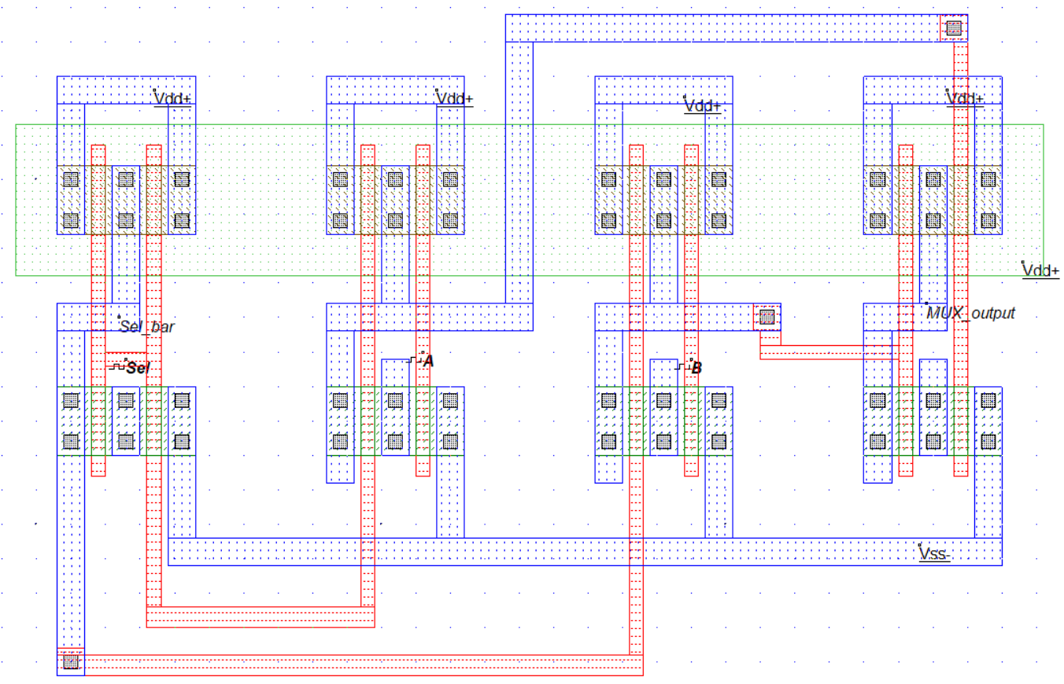

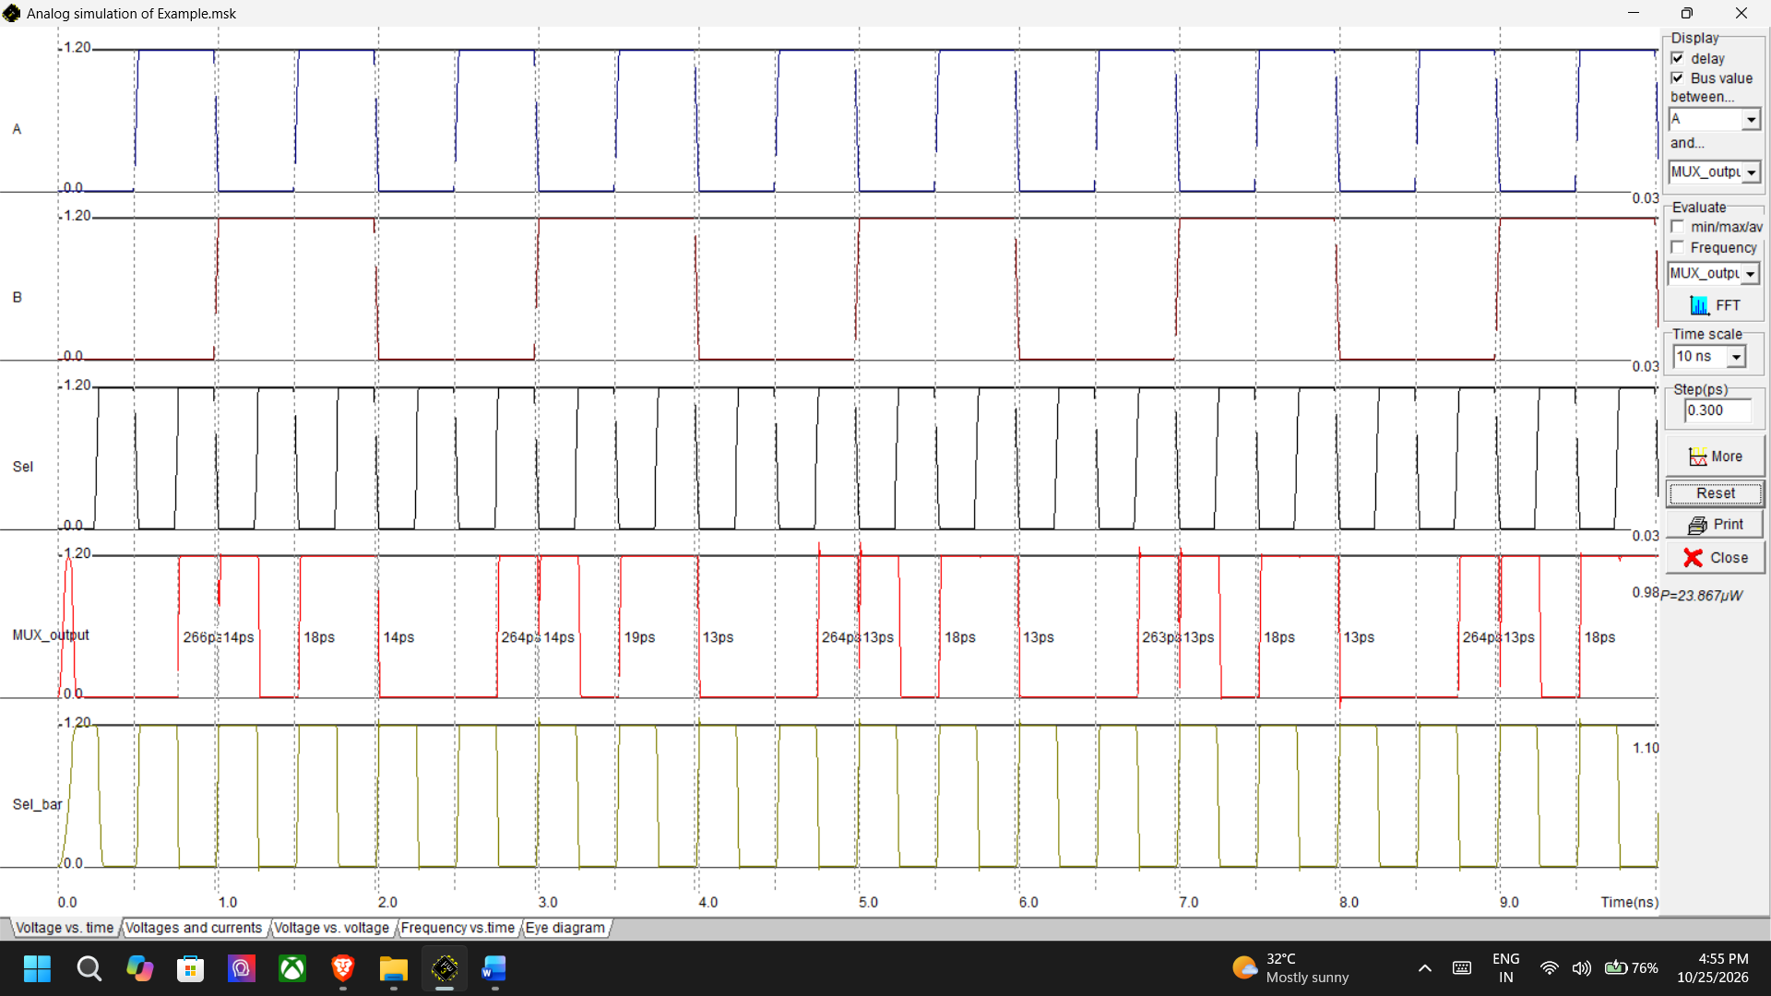

2:1 Mux using Tranmission gates :

